Project Report

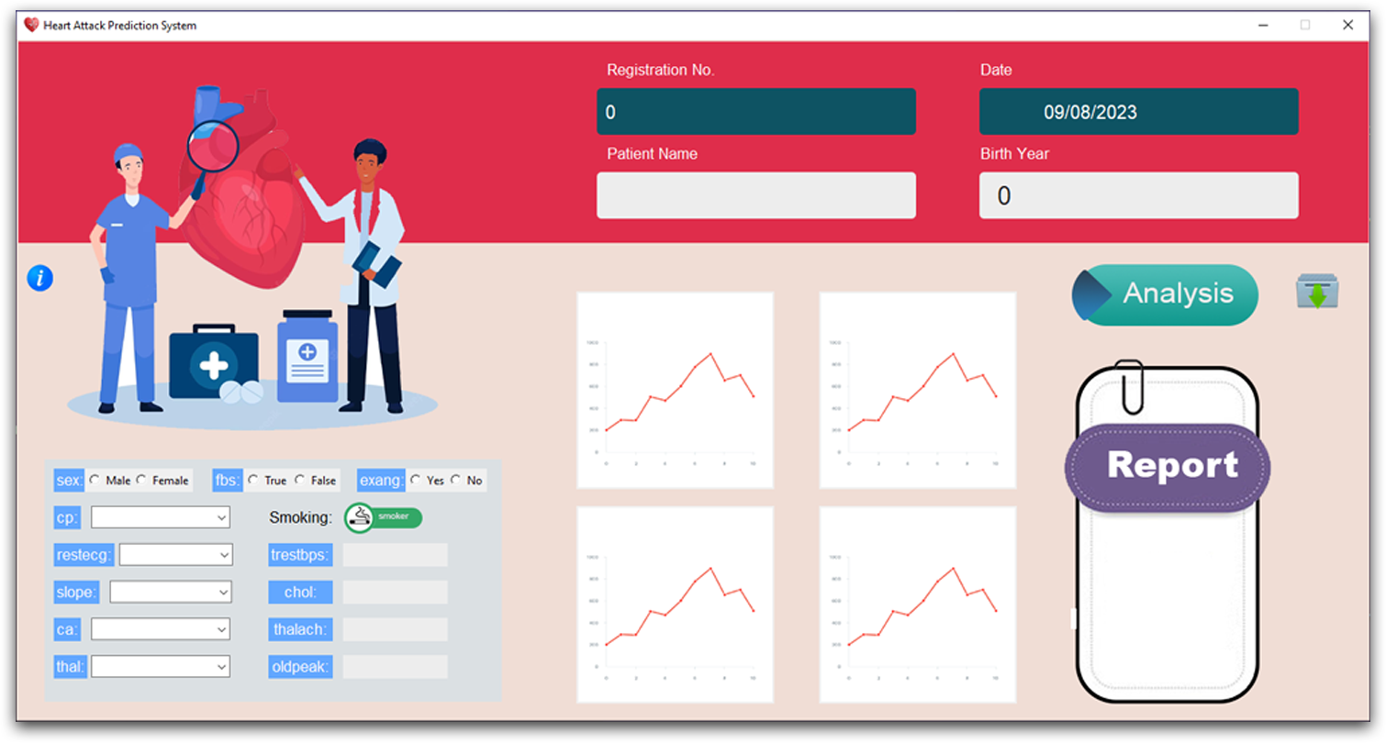

Heart Attack Prediction System
Python Project to Predict Heart Attack Prediction System

Heart attack prediction is the process of utilizing machine learning techniques to foresee the likelihood of a heart attack based on various health parameters. This is crucial in the medical field as it can save lives by predicting potential heart problems before they occur. The system integrates Python, Tkinter for the GUI, and MySQL for database management, providing an efficient and user-friendly tool for medical professionals.


Your College Logo Your Institute Logo

Your College name Institute of Technology
Delhi-41327
Department of Computer Engineering
Academic Year 2024-25

Final Year/ mini Project Report
On
Heart Attack Prediction System

Submitted by:
Student1 Name and Roll Number
Student2 Name and Roll Number
Student3 Name and Roll Number
Student4 Name and Roll Number

actual name of the guide.
Guide

ABSTRACT
This is a project report on the “Heart Attack Prediction System” using Python programming concepts and a Tkinter GUI to develop the application. This tool is designed for the medical sector to analyze and store data in text form, addressing the difficulties of managing data and locating specific information. The project employs machine learning techniques to predict heart disease and uses a MySQL database for efficient data management. This project is ideal for final year projects and is available online for the first time.
Introduction

Heart attack prediction is the process of utilizing machine learning techniques to foresee the likelihood of a heart attack based on various health parameters. This is crucial in the medical field as it can save lives by predicting potential heart problems before they occur. The system integrates Python, Tkinter for the GUI, and MySQL for database management, providing an efficient and user-friendly tool for medical professionals.

What is Heart Attack?
A heart attack occurs when the flow of blood to the heart is severely reduced or blocked. The blockage is usually due to a buildup of fat, cholesterol and other substances in the heart (coronary) arteries. The fatty, cholesterol-containing deposits are called plaques. The process of plaque buildup is called atherosclerosis.
Sometimes, a plaque can rupture and form a clot that blocks blood flow. A lack of blood flow can damage or destroy part of the heart muscle.

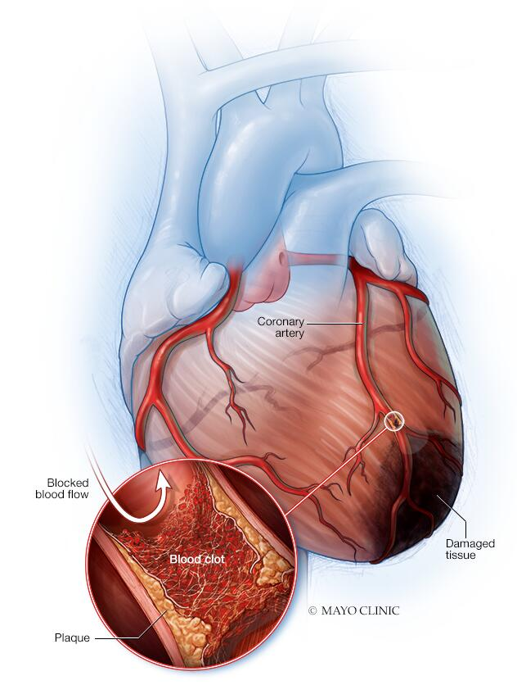
Heart attack
A heart attack occurs when an artery that sends blood and oxygen to the heart is blocked. Fatty, cholesterol-containing deposits build up over time, forming plaques in the heart's arteries. If a plaque ruptures, a blood clot can form. The clot can block arteries, causing a heart attack. During a heart attack, a lack of blood flow causes the tissue in the heart muscle to die.
A heart attack is also called a myocardial infarction.

Symptoms
Symptoms of a heart attack vary. Some people have mild symptoms. Others have severe symptoms. Some people have no symptoms.
Common heart attack symptoms include:
- Chest pain that may feel like pressure, tightness, pain, squeezing or aching
- Pain or discomfort that spreads to the shoulder, arm, back, neck, jaw, teeth or sometimes the upper belly
- Cold sweat
- Fatigue
- Heartburn or indigestion
- Lightheadedness or sudden dizziness
- Nausea
- Shortness of breath
Women may have atypical symptoms such as brief or sharp pain felt in the neck, arm or back. Sometimes, the first symptom sign of a heart attack is sudden cardiac arrest.
Some heart attacks strike suddenly. But many people have warning signs and symptoms hours, days or weeks in advance. Chest pain or pressure (angina) that keeps happening and doesn't go away with rest may be an early warning sign. Angina is caused by a temporary decrease in blood flow to the heart.

Risk Factors
Heart attack risk factors include:
- Age. Men age 45 and older and women age 55 and older are more likely to have a heart attack than are younger men and women.
- Tobacco use. This includes smoking and long-term exposure to second-hand smoke. If you smoke, quit.
- High blood pressure. Over time, high blood pressure can damage arteries that lead to the heart. High blood pressure that occurs with other conditions, such as obesity, high cholesterol or diabetes, increases the risk even more.
- High cholesterol or triglycerides. A high level of low-density lipoprotein (LDL) cholesterol (the "bad" cholesterol) is most likely to narrow arteries. A high level of certain blood fats called triglycerides also increases heart attack risk. Your heart attack risk may drop if levels of high-density lipoprotein (HDL) cholesterol — the "good" cholesterol — are in the standard range.
- Obesity. Obesity is linked with high blood pressure, diabetes, high levels of triglycerides and bad cholesterol, and low levels of good cholesterol.
- Diabetes. Blood sugar rises when the body doesn't make a hormone called insulin or can't use it correctly. High blood sugar increases the risk of a heart attack.
- Metabolic syndrome. This is a combination of at least three of the following things: enlarged waist (central obesity), high blood pressure, low good cholesterol, high triglycerides and high blood sugar. Having metabolic syndrome makes you twice as likely to develop heart disease than if you don't have it.
- Family history of heart attacks. If a brother, sister, parent or grandparent had an early heart attack (by age 55 for males and by age 65 for females), you might be at increased risk.
- Not enough exercise. A lack of physical activity (sedentary lifestyle) is linked to a higher risk of heart attacks. Regular exercise improves heart health.
- Unhealthy diet. A diet high in sugars, animal fats, processed foods, trans fats and salt increases the risk of heart attacks. Eat plenty of fruits, vegetables, fiber and healthy oils.
- Stress. Emotional stress, such as extreme anger, may increase the risk of a heart attack.
- Illegal drug use. Cocaine and amphetamines are stimulants. They can trigger a coronary artery spasm that can cause a heart attack.
- A history of preeclampsia. This condition causes high blood pressure during pregnancy. It increases the lifetime risk of heart disease.
- An autoimmune condition. Having a condition such as rheumatoid arthritis or lupus can increase the risk of a heart attack.

Requirement and Specification

Hardware Requirements:

PROCESSOR : Intel(R) Core (TM)i5-4300G1 CPU@1.90GHz ,2501 MHz
HARD DISK : 500 MB
RAM : 8 GB

Software Requirements:
OPERATING SYSTEM : Window7/8/10/11 , Linux, Mac etc.
PROGRAMMING LANGUAGE : Python (version 3.10.5)
IDE USED : Visual Studio

Machine Learning Algorithm Implementation: Logistic Regression for Heart Disease Prediction

Introduction: This report describes the implementation of a machine learning algorithm to predict the presence of heart disease using logistic regression. Logistic regression is a statistical technique used for binary classification tasks, where the target variable has two possible outcomes. In this case, the target variable indicates whether a patient has heart disease (1) or not (0).
1. Data Loading and Preprocessing:
- The heart disease dataset ('heart.csv') is loaded into a Pandas DataFrame for analysis and modeling.
- Various exploratory data analysis (EDA) tasks are performed, such as checking for missing values, statistical measures, and the distribution of the target variable.
2. Feature Engineering:
- Features (X) and the target variable (Y) are separated from the dataset.
- Features represent various patient characteristics, such as age, sex, blood pressure, cholesterol levels, etc.
3. Train-Test Split:
- The dataset is divided into training and testing sets using the train_test_split function from scikit-learn.
- This step ensures that the model is trained on one portion of the data and evaluated on another portion to assess its generalization performance.
4. Model Training:
- A logistic regression model is instantiated and trained using the training data.
- Logistic regression fits a sigmoid curve to the data, modeling the probability of a patient having heart disease based on their features.
5. Model Evaluation:
- The accuracy of the trained model is evaluated on both the training and testing datasets using the accuracy_score function from scikit-learn.
- Accuracy measures the proportion of correctly predicted outcomes over all predictions made by the model.
6. Prediction:
- The trained model can be used to make predictions on new, unseen data.
- The code includes commented-out lines for making predictions on new data. However, some corrections may be needed in the prediction section for clarity and correctness.
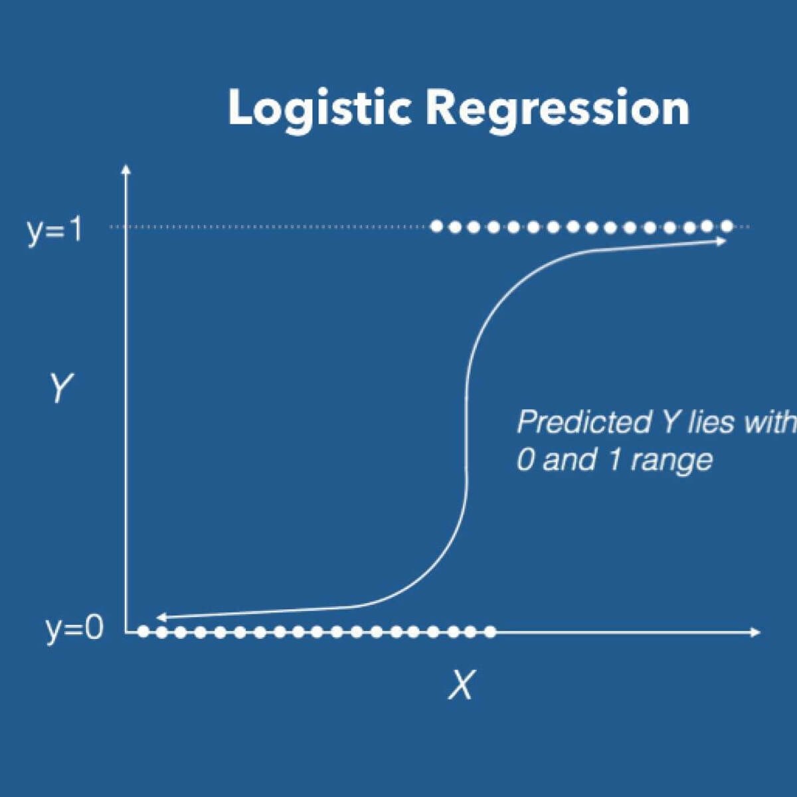
Heart attack prediction system using Tkinter

Python offers multiple options for developing GUI (Graphical User Interface). Out of all the GUI methods, tkinter is the most commonly used methods. It is a standard python interface to the Tk GUI toolkit shipped with Python. Python with tkinter outputs the fastest and easiest way to create the GUI applications. Now, it’s upto the imagination or necessity of developer, what he/she want to develop using this toolkit.
To create a tkinter:
- Importing the module - tkinter
- Create the main window (container)
- Add any number of widgets to the main window.
- Apply the event Tigger on the main window.
Let’s create a GUI based simple Real-time Weather detection application which can give Weather details of any cities.
Modules required:
Os
Datetime
Matplotlib
Numpy
Pandas
Sklearn
Logistic Regression

Heart Attack Application

How to start:
It is a quite easy work work with python , in this method we have used few advance libraries like tkinter, os,numpy, pandas, sklearn, datetime etc

How to start in few simple steps
1. Open Terminal, and install all required modules .
- pip install numpy== 1.26.4
- pip install pandas== 2.2.2
- pip install scikit-learn
- pip install matplotlib==3.5.32.
Then open python file with the help of IDE, or by double click on file.

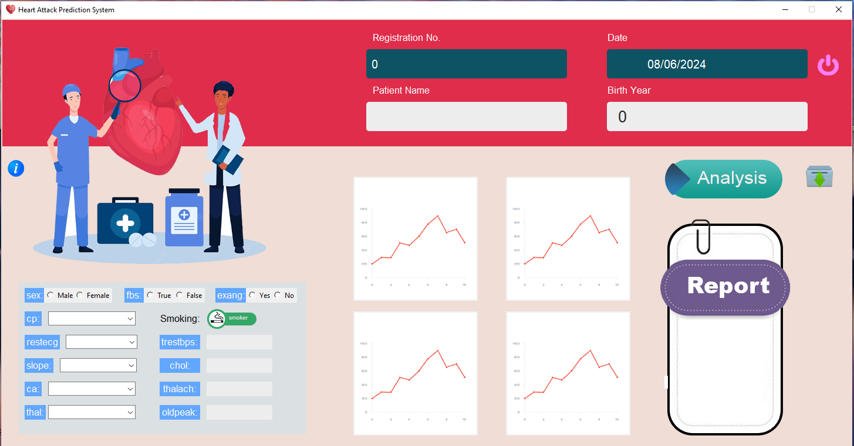
It is the first interface of Heart Attack Application, which is completely design with the help of python tkinter.
It contain all the features with advance modules and working..
There is list of work we can perform , in this project:
- Prediction
- Database
- Generate report
- Information of test

3. Click on info button , to get more information about all entries
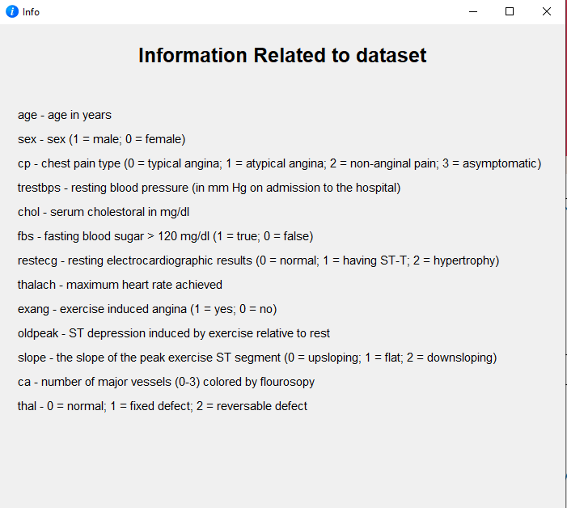

3. Let’s start with input option:
On putting all the required details given in the software interface ,click on the  button.

Final Result:

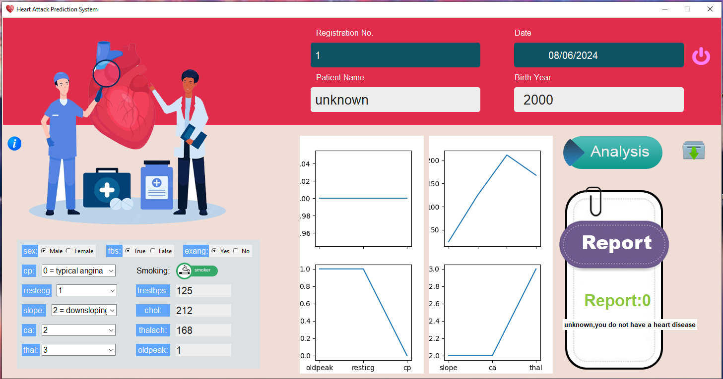

Advantage

Personalized Risk Assessment
Early Detection
Improving Patient Outcomes
Integration with Electronic Health Record
Continous Learning and Improvement

Disadvantage

Data Quality and Bias
Interpretabilty
Overfitting
Ethical and Privacy Concerns
False Positives and Negaives

Conclusion

In conclusion, the development of a heart attack prediction system using machine learning presents both significant opportunities and challenges in healthcare. By leveraging advanced algorithms to analyze patient data, such as demographics, medical history, and diagnostic test results, the system can offer early detection and personalized risk assessment, leading to improved patient outcomes and resource allocation efficiency. However, the success of such a system depends on addressing key challenges, including ensuring data quality and representativeness, enhancing model interpretability and transparency, mitigating the risk of overfitting, and addressing ethical and privacy concerns. Despite these challenges, the potential benefits of a heart attack prediction system are substantial, offering healthcare providers valuable decision support tools to better prioritize patient care and interventions. Moving forward, collaboration between data scientists, healthcare professionals, policymakers, and regulatory bodies will be essential to develop robust, ethical, and clinically relevant predictive models that ultimately improve patient care and outcomes in the management of cardiovascular health.

Future scope:
- Integration with Wearable Devices: As wearable health monitoring devices become more prevalent, integrating data from these devices into heart attack prediction systems could enhance the accuracy and timeliness of risk assessments. Real-time monitoring of physiological parameters such as heart rate, blood pressure, and activity levels can provide valuable insights into an individual's cardiovascular health status.

- Advanced Machine Learning Techniques: Exploring advanced machine learning techniques, such as ensemble methods, deep learning, and reinforcement learning, may further improve the predictive performance of heart attack prediction systems. These techniques can capture complex relationships within the data and adapt to evolving patterns over time.

- Remote Patient Monitoring: With the increasing adoption of telemedicine and remote patient monitoring, there is an opportunity to develop heart attack prediction models that can be deployed in virtual healthcare settings. Remote monitoring platforms can enable continuous assessment of patient risk factors and early detection of warning signs, facilitating timely interventions and follow-up care.

- Predictive Analytics for Precision Medicine: Integrating genetic and genomic data into heart attack prediction models can enable personalized risk stratification and treatment recommendations based on an individual's genetic predisposition to cardiovascular diseases. Incorporating biomarkers and omics data can enhance the precision and individualization of predictive analytics in cardiovascular medicine.

- Population Health Management: Heart attack prediction systems can contribute to population health management initiatives by identifying high-risk cohorts within communities or patient populations. Targeted interventions, preventive strategies, and public health campaigns can be tailored to address the specific needs of at-risk groups, reducing the overall burden of cardiovascular disease on healthcare systems.

- Clinical Decision Support Systems: Embedding heart attack prediction algorithms into clinical decision support systems (CDSS) can assist healthcare providers in making evidence-based decisions at the point of care. Integrating predictive analytics seamlessly into electronic health record (EHR) systems can streamline clinical workflows and improve the delivery of personalized care.

- Longitudinal Data Analysis: Longitudinal analysis of patient data over extended periods can provide insights into the trajectory of cardiovascular health and disease progression. Monitoring changes in risk factors, treatment responses, and outcomes over time can inform personalized risk management strategies and optimize long-term patient outcomes.

